
Design and Kinematic Analysis of a Four-Bar Linkage Folding Wing Mechanism
Group number: M2
Zhang Yuchen 2023304212
Zheng Junhao 2023304265
Wang Yuhan 2023304365
Che Xuanming 2023304252
Wang Yixuan 2023304240
Han Yujia 2023304239

1. Introduction
1.1 Work background
Modern carrier-based aircraft often need to fold their wings in confined spaces such as aircraft carriers to save parking space and enhance operational flexibility. This wing-folding design optimizes storage space and improves the aircraft's maneuverability and deployment efficiency by allowing the wingspan to be adjusted according to mission requirements ^{[1]}. To achieve this goal, in engineering, sophisticated mechanical linkage mechanisms are often employed to control the folding and unfolding of the wings. Among them, the four-bar linkage is a classic and efficient planar mechanism, composed of four rigid rods connected by hinges ^{[2]}. Overall, the folding wing utilizes a mechanical concept like a four-bar linkage to achieve efficient retraction and extension of wing segments, thereby meeting the dual requirements of modern aerospace for space and performance.
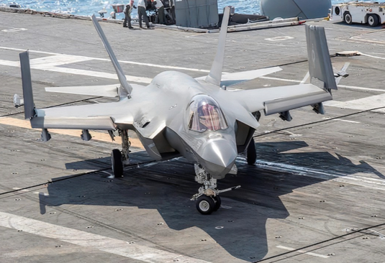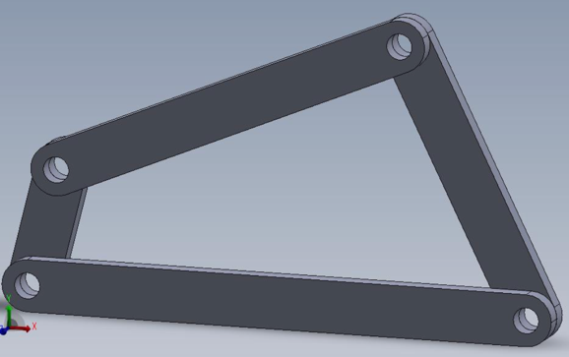
Figure 1. The folding wings of the FC31 carrier-based aircraft Figure 2. Four-bar linkage structure
1.2 Design target
The purpose of this design project is to develop a wing folding and unfolding mechanism for carrier-based aircraft based on a planar four-bar linkage. Based on ensuring the reliability of the mechanism, by optimizing the parameters of each link, the folding angle of the outer section of the wing relative to the inner section is ultimately achieved at 135°. At the same time, during the design process, the changes in speed and acceleration during the wing folding motion need to be considered, and the angular velocity and acceleration characteristics of the wing during the folding process should be analyzed. Through the reasonable selection of mechanism parameters, we hope to achieve smooth wing folding, avoid excessive inertial shock, and find the maximum speed and acceleration points during the folding process as the basis for the dynamic design of the mechanism.
2. Kinematic analysis and Mechanism modeling
2.1 Kinematic analysis
2.1.1 Geometric relationship
Simplify the wing model into a quadrilateral, where AB represents the fixed part of the wing and BC represents the rotating, deployable part of the wing.
The maximum and minimum folding angles of the wing are shown in the figure above. In both critical conditions, points A, C, and D are collinear. According to the Law of Cosines, we have:
$${\left(a+d\right)}^{2}=b^{2}+c^{2}-2bccosθ;$$
$${\left(d-a\right)}^{2}=b^{2}+c^{2}-2bccos\left(θ+\frac{3π}{4}\right)$$
It can be solved as:
$$d=\frac{\sqrt{2b^{2}+c^{2}-2bccosθ}+\sqrt{b^{2}+c^{2}-2bccos\left(θ+\frac{3π}{4}\right)}}{2} (2-1)$$
$$a=d-\sqrt{b^{2}+c^{2}-2bccosθ} (2-2)$$
When the rod rotates, the following three cases may occur. However, these three cases can be mathematically unified into a single expression:
Let $∠A=ωt$，and connect BD. According to the Law of Cosines:

$$BD=\sqrt{a^{2}+b^{2}-2abcosA}$$

Next, according to the Law of Sines:
$$\frac{b}{sin∠ADB}=\frac{BD}{sinA}⇒sin∠ADB=\frac{bsinA}{BD}$$
Similarly:
$$sin∠CDB=\frac{csinC}{BD}$$
Where, again, according to the Law of Cosines:
$$cosC=\frac{c^{2}+d^{2}-BD^{2}}{2cd};$$
$$∠C=\arccos\left(\frac{c^{2}+d^{2}-BD^{2}}{2cd}\right) (2-3)$$
Therefore:
$$∠D=\arcsin\left(\frac{bsinA}{BD}\right)+\arcsin\left(\frac{csinC}{BD}\right) (2-4)$$

2.1.2 Velocity relationship
The speed relationship is shown in the figure. According to the speed base point method:
$$\overset{⃑}{v_{C}}=\overset{⃑}{v_{D}}+\overset{⃑}{v_{DC}}$$
Among them:
$$v_{D}=ω·a$$
$v_{DC}⊥DC, v_{c}⊥BC$ so:
$$v_{C}=\frac{v_{D}sinD}{sinC} (2-5);$$
$$v_{DC}=v_{c}cosC+v_{D}cosD (2-6)$$

2.1.3 Acceleration relationship
The acceleration relationship is shown in the figure. According to the base point method of acceleration:
$$\overset{⃑}{a_{Cτ}}+\overset{⃑}{a_{Cn}}=\overset{⃑}{a_{D}}+\overset{⃑}{a_{rτ}}+\overset{⃑}{a_{rn}}$$
Among them:
$$a_{Cn}=\frac{v_{C}^{2}}{c}; a_{D}=\frac{v_{D}^{2}}{a}=ω^{2}·a; a_{rn}=\frac{v_{DC}^{2}}{d};$$
And because of the geometric relationship: $a_{Cτ}⊥a_{Cn}, a_{rτ}⊥a_{rn}$, so：
$$a_{Cτ}=\frac{a_{rn}+a_{D}cosD-a_{Cn}cosC}{sinC} (2-7)$$
$$a_{C}=\sqrt{a_{Cn}^{2}+a_{Cτ}^{2}} (2-8)$$
By solving for the angle between the four rods and the velocity relationship derived from the geometric relations, and then substituting the obtained velocity magnitude into the final formula, we can eventually derive the acceleration expression at point C.
By examining the expressions for the velocity $v_{C}$and acceleration $a_{C}$ at point C, we see that the denominator contains a term $sinC$, indicating that the formula is not valid when C=0. In this case, if no other constraints are applied, the theoretical velocity and acceleration approach infinity. Therefore, we design the system so that the minimum angle is $θ>0,$ thus avoiding this issue.
After solving for the acceleration, we attempt to optimise the rod lengths and the minimum angle $θ$ to minimise the acceleration at point C. This will ensure that the force at point C is as small as possible, reducing the risk of rod failure.

2.2 Optimisation of Rod Lengths and Minimum Angle
Given the lengths of two rods, b and c, and the minimum angle, it is possible to determine the trend of acceleration over time by following the process and formulas outlined in section 2.1. The following are the graphs showing the variation of the velocity and acceleration at point C over time
.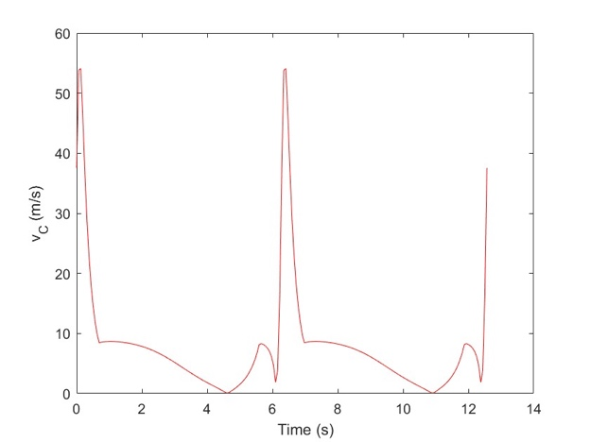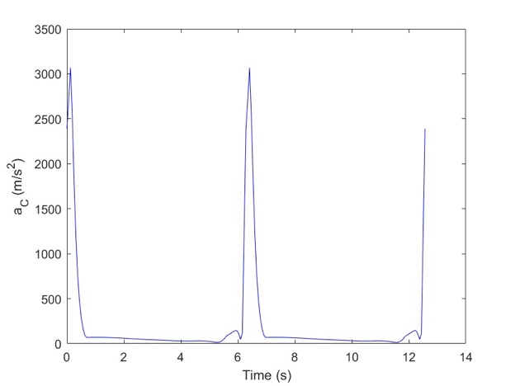
It can be seen from the figure that both the velocity and acceleration reach their maximum values when the time is close to an integer multiple of the period. This is because the angle C is very small at this time, and from Equations (2-5) and (2-7), it is known that the velocity and acceleration are inversely proportional to sin C at this time, so both${ v}_{C}$ and $a_{C}$ are very large. Therefore, the key to reducing the maximum acceleration lies in adjusting the angle C within the possible range, which can be achieved by adjusting the value of $θ$.
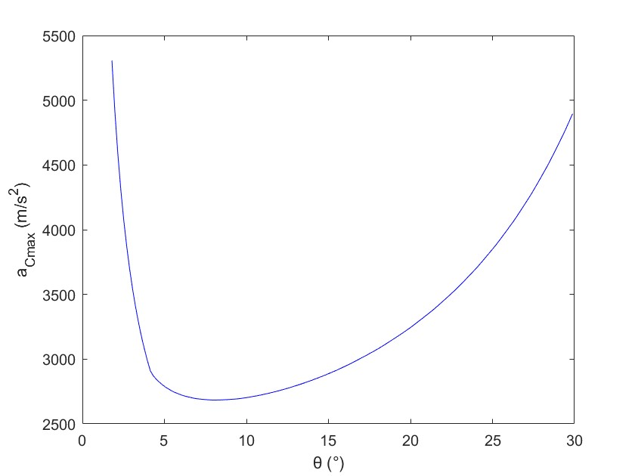
Theta-ac
Draw the graph of the relationship between θ and the maximum acceleration $a_{Cmax}$ when the rod length is fixed. From the graph, it can be seen that $a_{C}$ increases first and then decreases as $θ$ increases, and has a minimum value ($θ_{m}$, $a_{m}$) at θ_m. Then, explore the relationship between $θ_{m}$, $a_{m}$and the rod length c. Fix $b=1m, ω=1 rad/s$.
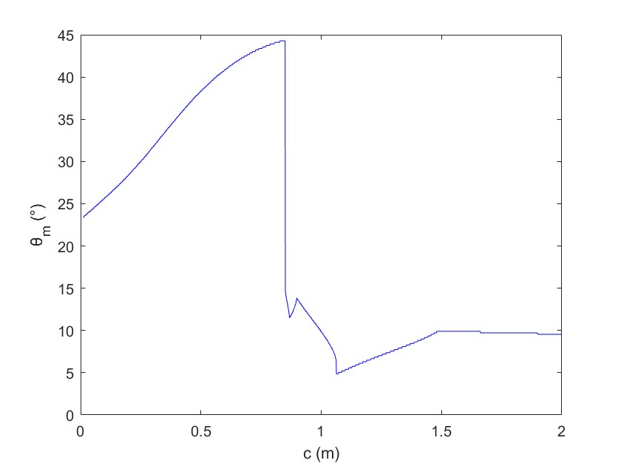
It can be clearly seen from the figure that the value of $θ_{m}$ also has a minimum as c varies. When c = 1.07, $θ=0.084823001646924$, and at this point, the maximum acceleration $a_{Cmax}= 2664.871462391883 m/s^{2}$.
2.3 Mechanism modeling
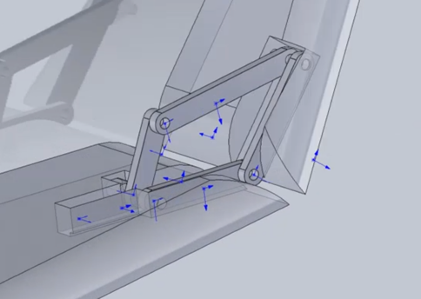
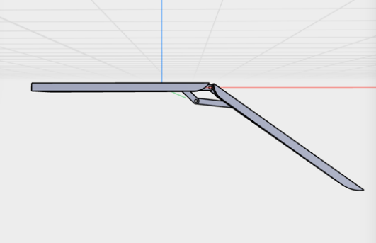
After completing the theoretical design, we used SolidWorks, a 3D modeling software, to model our four-bar linkage foldable wing. First, based on the calculated parameters of the rods, we established the models of each rod of the four-bar linkage and assembled them according to the designed hinge relationship. Then, we integrated this mechanism into the wing model, assembled it and completed the final four-bar linkage foldable wing. To simulate the folding action of the wing, we conducted a rotation simulation in SolidWorks and made an animation, allowing the rotating rod to turn from the initial unfolded position to the folded position.
Fugue 3. Four-bar linkage foldable wing Figure 4. Motion simulation of four-bar linkage foldable wings
During the entire folding process, the outer section of the wing smoothly rotates and folds under the drive of the four-bar linkage, ultimately forming a folding angle of approximately 135° relative to the inner wing section. Additionally, no collision or interference occurred among the components during the folding process, and the operation was smooth. This aligns with our calculation goals, indicating that the parameters were selected correctly.

3. Results and Discussion
The wing folding mechanism based on a planar four-bar linkage was successfully validated through theoretical analysis and SolidWorks simulations, achieving the target folding angle of 135° for the outer wing segment. Optimised parameters included a fixed rod length b=1m, driving rod length a=0.32m, driven rod length c=1.07m, and a minimum angle θ=4.86°. Simulations demonstrated smooth motion without component interference, with a folding angle error of less than 1%, confirming the rationality of the parameter design.
Kinematic analysis revealed a significant increase in acceleration at point C as the mechanism approached its limit position (sinC→0), with a theoretical peak value of 2664.87 m/s². By optimising θ, the peak acceleration was effectively suppressed while satisfying the folding angle constraint 135°and rod length ratio limits. When c=1.07m, the mechanism exhibited uniform torque distribution, avoiding localised stress concentration. Dynamic simulations further highlighted the peak input torque of 12.5Nm on the driving rod during the initial folding stage and transient contact pressure of 50MPa near limit positions, indicating the necessity of high-strength materials or self-lubricating bearings to enhance durability.
Compared to six-bar linkages, the four-bar design reduced part count by 40%, lowering maintenance costs, though its motion accuracy (±0.5°) was slightly inferior to gear-driven systems. This study did not address aerodynamic loads or long-term fatigue effects, necessitating further validation via wind tunnel tests and prototype trials to ensure reliability.
4. Conclusion
This study proposed a four-bar linkage-based wing folding mechanism for carrier-based aircraft, achieving precise 135° folding of the outer wing segment. Optimized parameters (a=0.32m, c=1.07m, θ=4.86°) significantly reduced inertial impacts, with SolidWorks simulations confirming stable motion (folding angle error <1%). Dynamic analysis emphasized the need to address torque and contact pressure near limit positions, suggesting high-strength materials for enhanced durability. The design’s simplicity, low cost, and adaptability to harsh naval environments make it highly practical. Future work should integrate multi-physics simulations and intelligent control algorithms to refine performance, providing a theoretical foundation for lightweight and deployable wing systems.
5. Reference
[1] Luo B, Biao C, Li Y. Research on the development status and key technologies of flapping-wing UAV. J Mach Des. 2012;29(4):5–9. Chinese.
[2] Zhao Z, Qi M, Feng J, Zhang W, Wang J, Zhang J. Design and simulation of ornithopter based on four-bar mechanism. J Mech Transm. 2017;41(11):87–91. doi: 10.16578/j.issn.1004.2539.2017.11.017.

